Title: | AEP QRO.  Window Lifter
Authors: Habib Alejandro Apez González.
Estefanía López Villagómez.

History
Issue status  (Index) | Maturity/Date  (draft/invalid/valid)  (dd-mmm-yyyy) | Author  Department | Check/Release  Department | Description
1 | Draft  20-Oct-2017 | Habib Apez.  Estefanía López. | Continental Engineers and authors. | Initial Draft
2 | Draft  23-Oct-2017 | Habib Apez.  Estefanía López. | Continental Engineers and authors. | SW conceptual design section diagrams added.
3 | Draft  25-Oct-2017 | Habib Apez.  Estefanía López. | Continental Engineers and authors. | Component breakdown and flow diagrams added.
4 | Draft  26-Oct-2017 | Habib Apez.  Estefanía López. | Continental Engineers and authors. | Function descriptions completed.
5 | Valid  27-Oct-2017 | Habib Apez.  Estefanía López. | Continental Engineers and authors. | First Release.
6 | Draft  02-Nov-2017 | Habib Apez.  Estefanía López. | Continental Engineers and authors. | Corrections based on feedback´s group included.
7 | Valid  03-Nov-2017 | Habib Apez.  Estefanía López. | Continental Engineers and authors. | Second Release.

Table of Contents
1 Purpose 5
2 Definitions and abbreviations 5
2.1 Definitions 5
2.2 Abbreviations 5
2.3 References 6
3 Realization constraints and targets 6
4 SW Conceptual design 6
4.1 Window Lifter Block Diagram 7
4.2 Implementation Block Diagram 7
4.3 Window Lifter Implementation 8
5 SW Component internal breakdown 8
5.1 Up Normal 9
5.2 Down Normal 9
5.3 One Touch Up 10
5.4 One Touch Down 10
5.5 Antipinch 11
5.6 Functional Decomposition 11
5.6.1 Main function descomposition at APP level 11
5.6.2 Main function descomposition at APP and HAL level 12
5.6.3 Window Lifter Flow Diagram 13
6 Function Description and Dynamic Behavior 14
6.1 MCAL 15
6.2 HAL 16
6.2.1 Button.c 17
6.2.2 Clock 21
6.2.3 Leds 22
6.2.4 Segmentbar 25
6.2.5 Timer 35
6.3 APP 39
6.3.1 Windowlifter 40

Purpose

A power window lifter is an automobile part which can be manipulated to up or down and other specific safety use control.

This project will work using two push buttons, one for the up movement, and the other one to down, these specific buttons are going to order to our product to simulate the window movement represented with a ten segment red light bar, this light will turn on to be a complete close window or turn off to get down as the user will wanted.

Each button have two modes, normal and one touch. The first one works to make all the track if you press for determinate time, and the second one is for only a part of the track with a quick movement.

There is to an extra function: Anti pinch this is a safety requirement than works only when the up movement is activated to prevent some kind of accidents, this stops the other move and make than our window down completely and remain stop for 5 seconds. Then our normal process continues.

The process our all the functions are scheduled in layers: MAL, HAL, APP. To simplify the final operations and delimit the functions with the option to continue adding other future operations.

Definitions and abbreviations

Definitions

MCAL | Microcontroller Abstraction Layer
HAL | Hardware Abstraction Layer
APP | Application Layer
SW | Software
HW | Hardware
GPIO | General Purpose Input/Output
LPIT | Low Power Interrupt Timer

Abbreviations

s | Second
ms | Milisecond

References
N° | Document name | Reference
1 | Window lifter requirements.docx | Continental
2 | V_Cycle Process | Continental
3 | V_Cycle Process Script.xlsx | Continental
4 | S32K1xx Series Reference Manual | NXP
5 | Naming Conventions.pdf | Continental
6 | https://www.iar.com/iar-embedded-workbench | IAR
7 | MISRA C:2012 March 2013 | Continental
8 | S32K1xx Data sheet | NXP

Realization constraints and targets

Window Lifter

The principal purpose is controlling a simulation window movement.

It will going to work with the interface of 3 different buttons, one will do the action to up, the other one will do the down and an extra will do the Antipinch mode.

There is going to be appreciable de action using a light to indicate it, blue to Up, Green to Down.

One restriction of the requirements is than this project only can have a ten segment bar led to simulate the movement.

Other restriction is the use of the board S32K144EVB-Q100.

SW Conceptual design

General window lifter system, it specifies the actions of the application with the interaction of the buttons and the corresponding light to the action they will going to do: Up, Down and Antipinch, to can make than the window shows.

Window Lifter Block Diagram
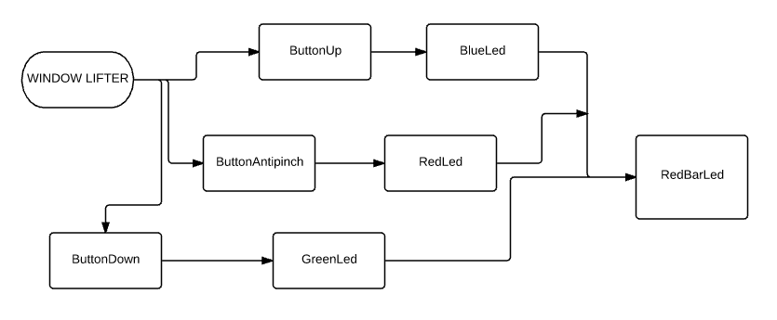

Implementation Block Diagram
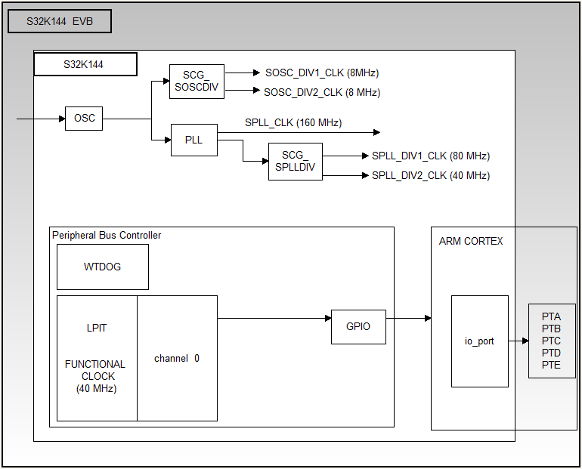

Window Lifter Implementation

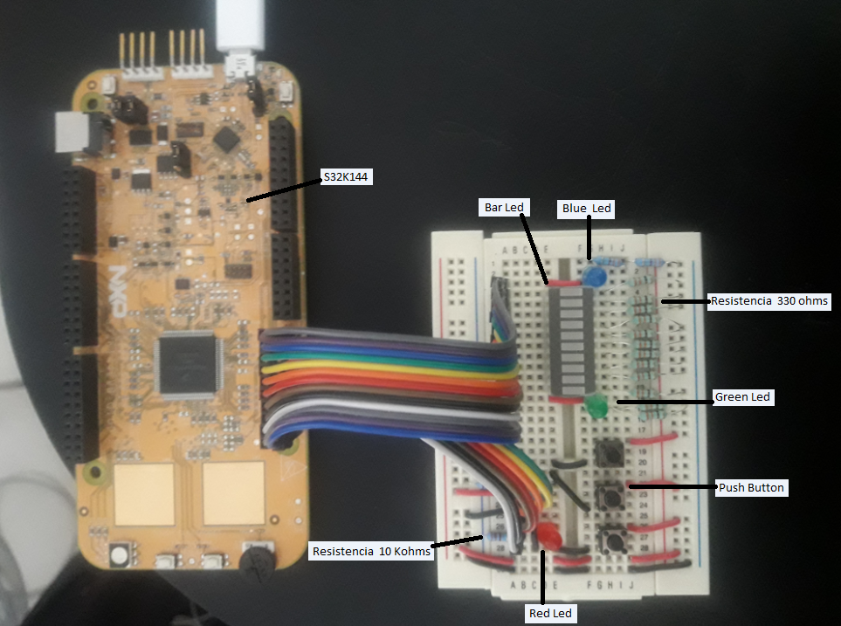

SW Component internal breakdown
In this section, the main functions in APP are described through a block diagrams. Each diagram shows the relation between that component and other components located in HAL and MCAL.

Up Normal
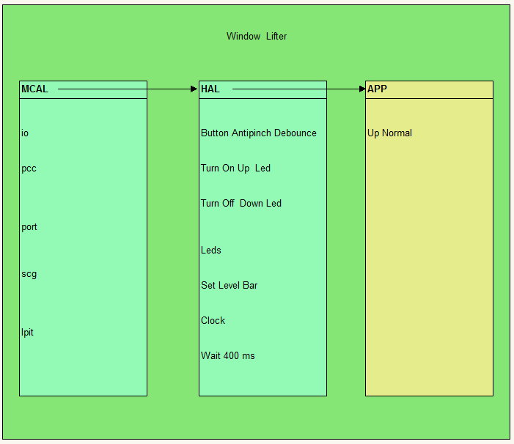

Down Normal
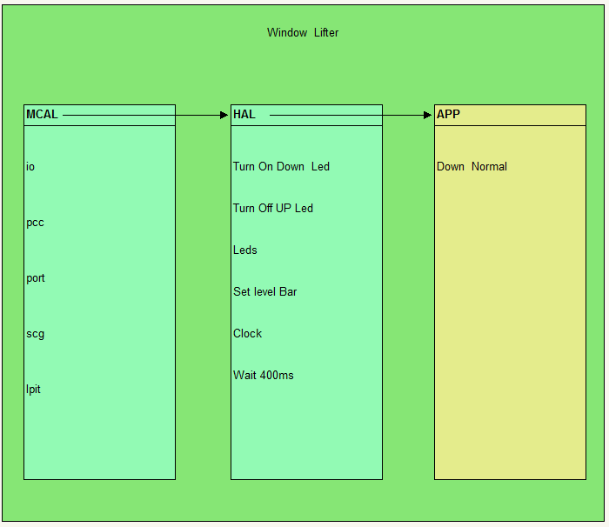

One Touch Up
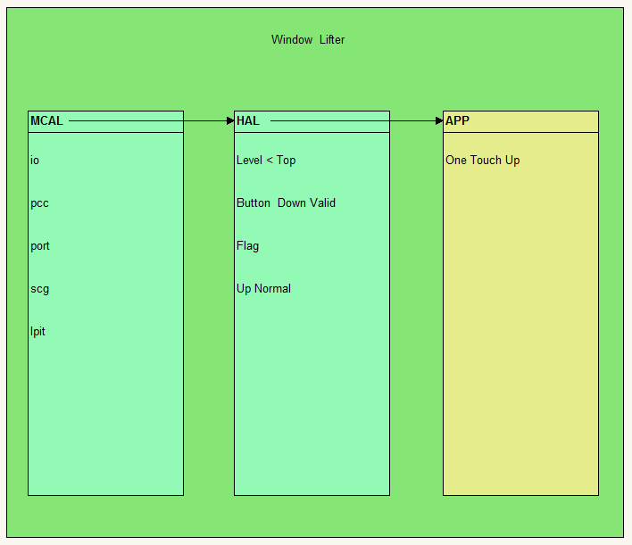

One Touch Down
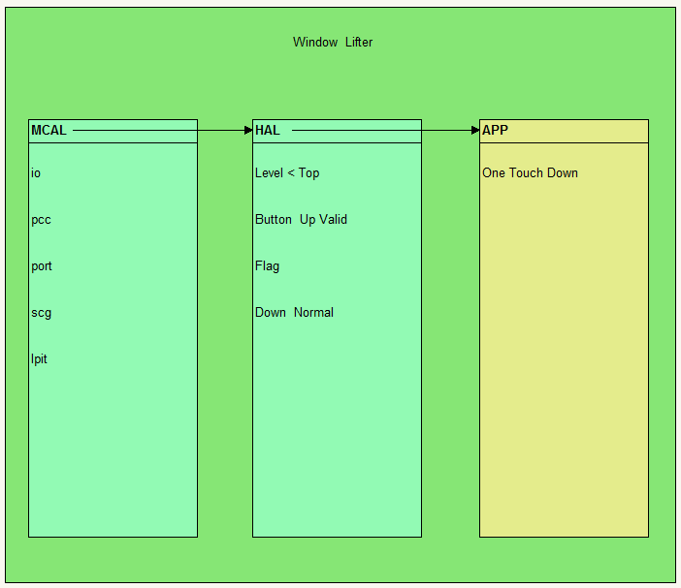

Antipinch
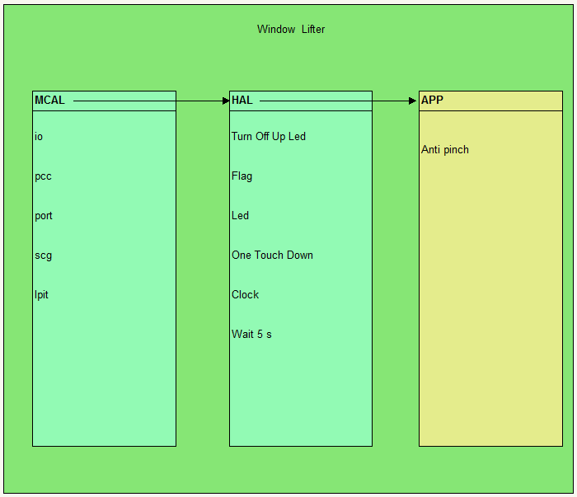

Functional Decomposition
Main function for the window lifter. Dependencies between main() and other functions in APP layer are shown in the following diagram.

Main function descomposition at APP level
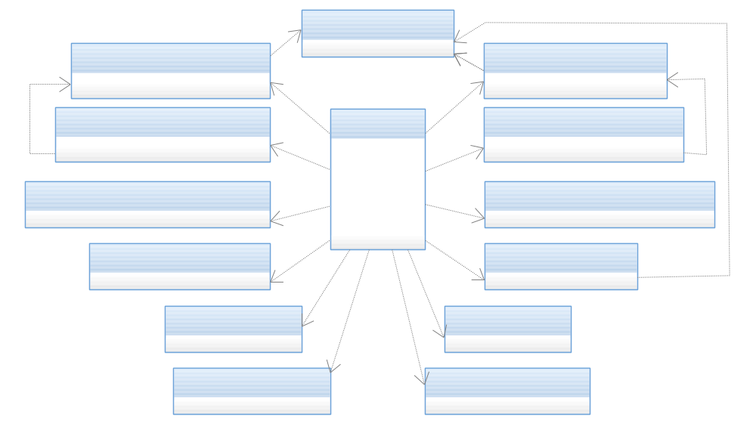

Main function descomposition at APP and HAL level

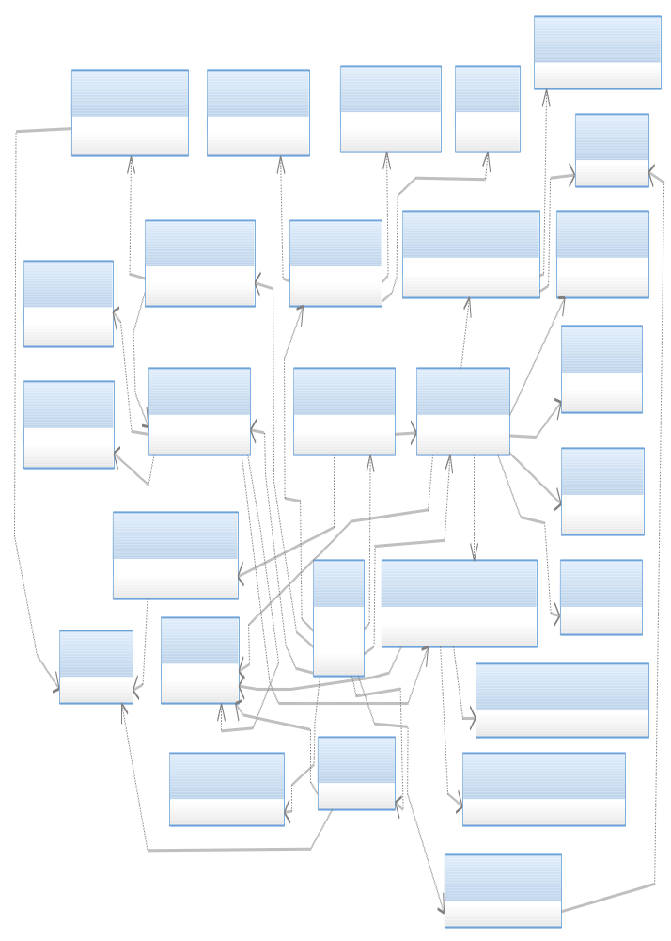

Window Lifter Flow Diagram

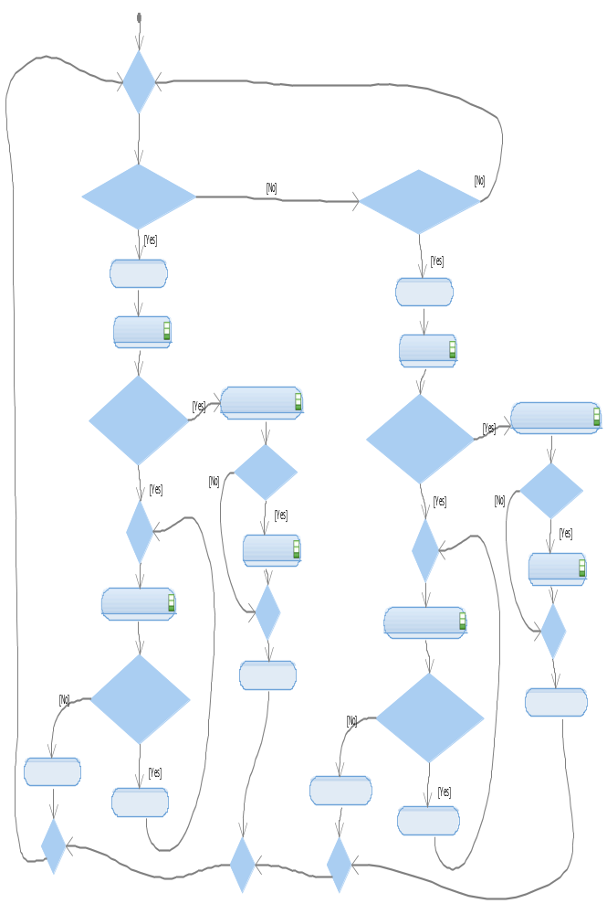

Function Description and Dynamic Behavior
The following image shows the modules developed and their corresponding layer.

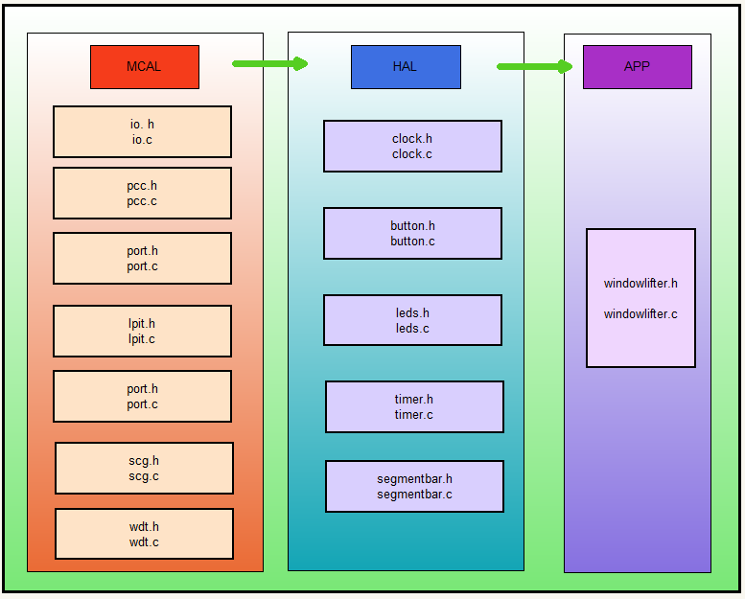

MCAL
MCAL has several modules such as: io, lpit, pcc, wdt, port and scg. The following image shows how each of these modules are conformed. Each module maps a set of registers of the microcontroller.

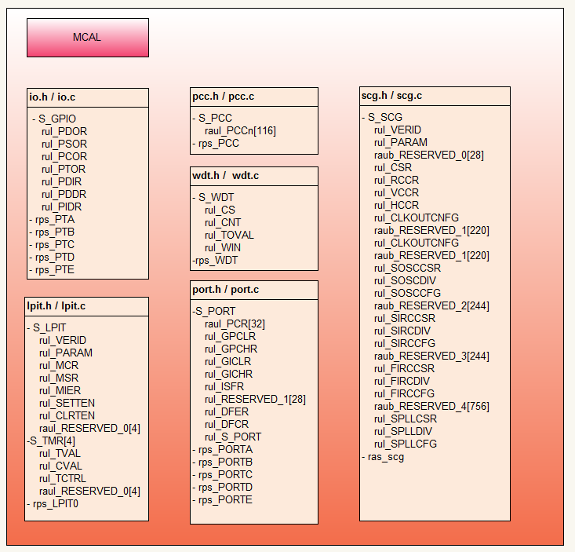

HAL
The modules to interact with the hardware are specified in MCAL. This layer contains the following modules: segmentbar, button, leds, timer and clock. The functions of each module are shown in the following figure.

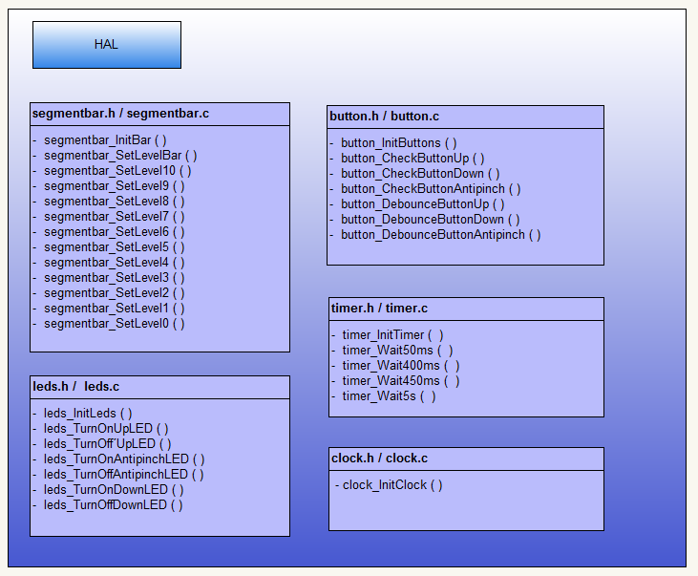

Button.c

Function Void button_InitButtons(void) [DSD-01]

Description | This function enables the specific pins in the ports to make them inputs, this are going represent the three button actions (UpButton, DownButton, AntipinchButton)
Parameter 1 | None
Return Value | void
Precondition | None preconditions, but the PCC.C .library must be include
Post condition | The pins now have the new register so then the buttons are functional.
Error Conditions | None

Dynamic Behavior
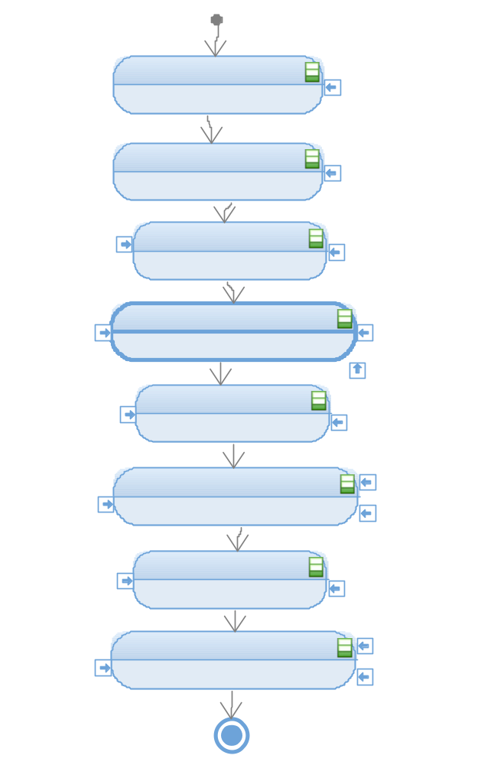

Function T_UBYTE button_CheckButtonUp(void) [DSD-02]

Description | Checks the state of the Pin 5 of the Port E configured as input.
Parameter 1 | None
Return Value | void
Precondition | The pin must have been configured as an input.
Post condition | The state (high 1 or low 0) should be returned.
Error Conditions | None

Dynamic Behavior
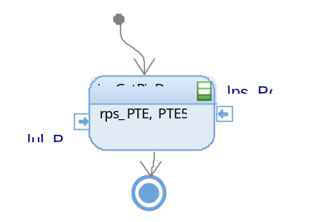

Function T_UBYTE button_CheckButtonDown(void) [DSD-03]

Description | Checks the state of the Pin 12 of the Port A configured as input.
Parameter 1 | None
Return Value | void
Precondition | The pin must have been configured as an input.
Post condition | The state (high 1 or low 0) should be returned.
Error Conditions | None

Dynamic Behavior
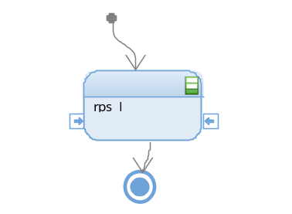

Function T_UBYTE button_CheckButtonAntipinch (void) [DSD-04]

Description | Checks the state of the Pin 13 of the Port A configured as input.
Parameter 1 | None
Return Value | void
Precondition | The pin must have been configured as an input.
Post condition | The state (high 1 or low 0) should be returned.
Error Conditions | None

Dynamic Behavior
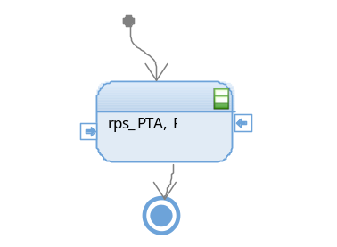

Function T_UBYTE button_DebounceButtonUp (void) [DSD-05]

Description | Reads the input of the Up button, then waits 50ms and then reads it once again to be sure that it is a valid press ant not a debounce.
Parameter 1 | None
Return Value | void
Precondition | The pin must have been configured as an input.
Post condition | Returns 1 if the press is valid and 0 if it is not valid.
Error Conditions | None

Dynamic Behavior
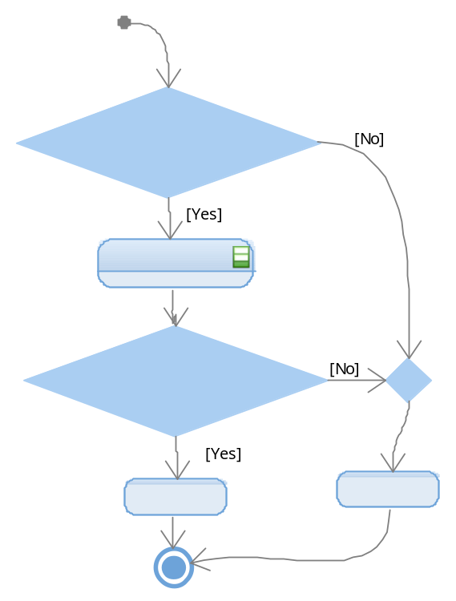

Function T_UBYTE button_DebounceButtonDown (void) [DSD-06]

Description | Reads the input of the Down button, then waits 50ms and then reads it once again to be sure that it is a valid press ant not a debounce.
Parameter 1 | None
Return Value | void
Precondition | The pin must have been configured as an input.
Post condition | Returns 1 if the press is valid and 0 if it is not valid.
Error Conditions | None

Dynamic Behavior

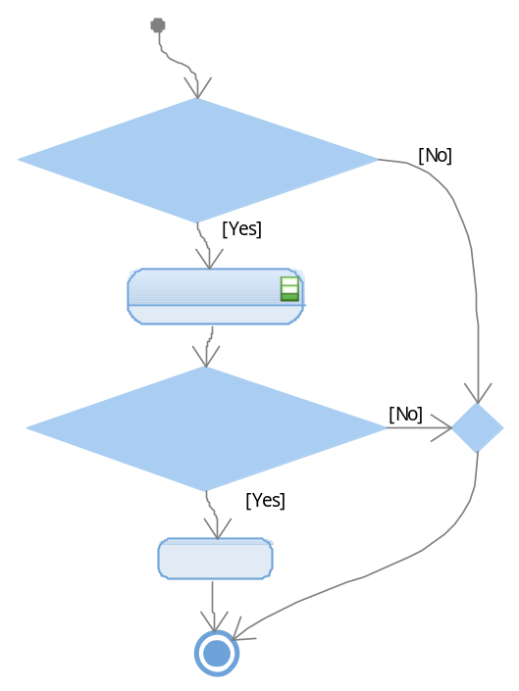

Function T_UBYTE button_DebounceButtonAntipinch (void) [DSD-07]

Description | Reads the input of the Antipinch button, then waits 50ms and then reads it once again to be sure that it is a valid press ant not a debounce.
Parameter 1 | None
Return Value | void
Precondition | The pin must have been configured as an input.
Post condition | Returns 1 if the press is valid and 0 if it is not valid.
Error Conditions | None

Dynamic Behavior

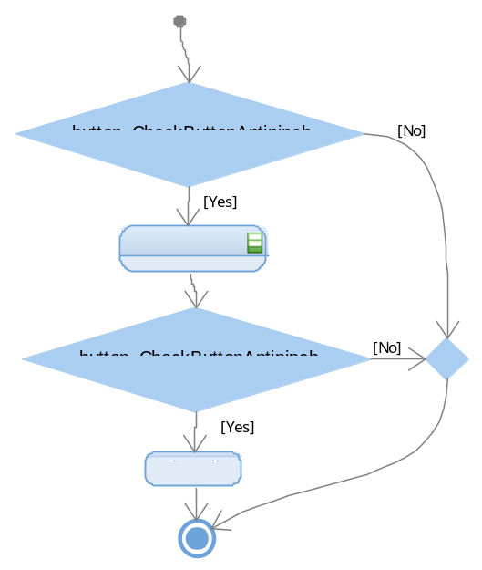

Clock

Function void clock_InitClock (void) [DSD-08]
Description | Initializes the System Clock, the PLL and configures the Run mode of the system oscillator.
Parameter 1 | None
Return Value | void
Precondition | None
Post condition | The system clock is initialized.
Error Conditions | None

Dynamic Behavior
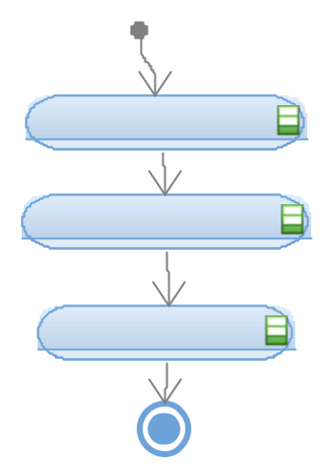

Leds

Function void leds_InitLeds(void) [DSD-09]

Description | Configures the Pin 13 of the PortA (Up LED), the Pin 5 of the PortE (Down LED)Down and the Pin 12 of the PortA (Antipinch LED) as outputs.
Parameter 1 | None
Return Value | void
Precondition | The clock of the Port A and E should have been initialized.
Post condition | The outputs of those pins are set low.
Error Conditions | None

Dynamic Behavior

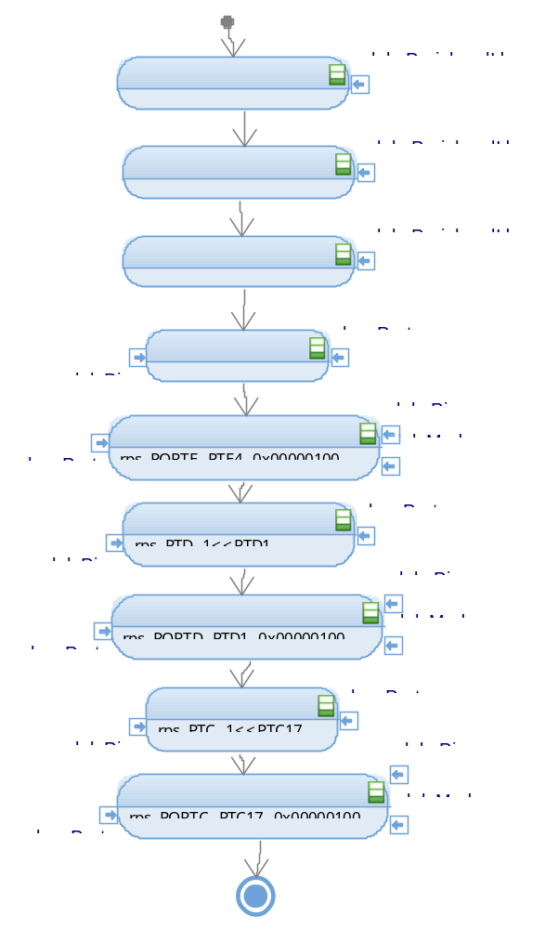

Function void leds_TurnOnUpLed (void) [DSD-10]
Description | Sets high the output of the Up LED located at Pin 4 of the PortE
Parameter 1 | None
Return Value | void
Precondition | The Pin should have been initialized as an output
Post condition | There is a high voltage level at the pin.
Error Conditions | None

Dynamic Behavior
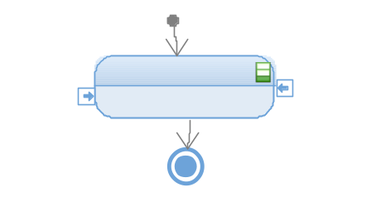

Function void leds_TurnOnDownLed (void) [DSD-11]

Description | Sets high the output of the Up LED located at Pin1 of the PortD
Parameter 1 | None
Return Value | void
Precondition | The Pin should have been initialized as an output
Post condition | There is a high voltage level at the pin.
Error Conditions | None

Dynamic Behavior
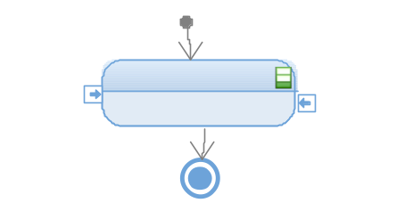

Function void leds_TurnOnAntipinchLed (void) [DSD-12]

Description | Sets high the output of the Up LED located at Pin17 of the PortC
Parameter 1 | None
Return Value | void
Precondition | The Pin should have been initialized as an output
Post condition | There is a high voltage level at the pin.
Error Conditions | None

Dynamic Behavior
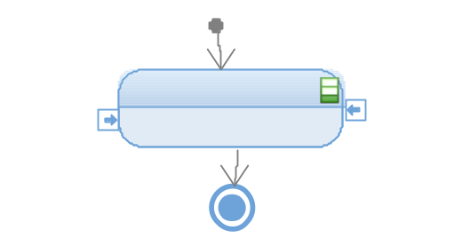

Function void leds_TurnOffUpLed (void) [DSD-13]
Description | Sets low the output of the Up LED located at Pin17 of the PortC
Parameter 1 | None
Return Value | void
Precondition | The Pin should have been initialized as an output
Post condition | There is a low voltage level at the pin.
Error Conditions | None

Dynamic Behavior
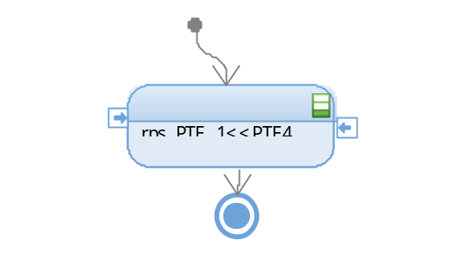

Function void leds_TurnOffDownLed (void) [DSD-14]

Description | Sets low the output of the Up LED located at Pin1 of the PortD
Parameter 1 | None
Return Value | void
Precondition | The Pin should have been initialized as an output
Post condition | There is a low voltage level at the pin.
Error Conditions | None

Dynamic Behavior

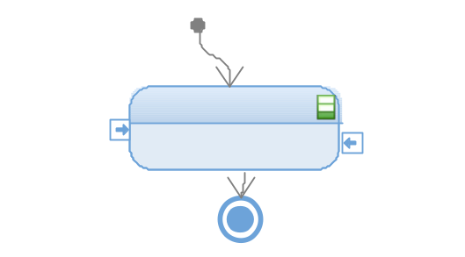

Function void leds_TurnOffAntipinchLed (void) [DSD-15]

Description | Sets high the output of the Up LED located at Pin17 of the PortC
Parameter 1 | None
Return Value | void
Precondition | The Pin should have been initialized as an output
Post condition | There is a high voltage level at the pin.
Error Conditions | None

Dynamic Behavior
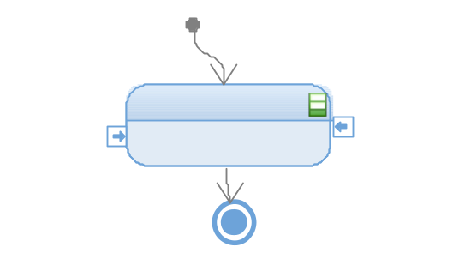

Segmentbar

Function void segmentbar_InitBar (void) [DSD-16]

Description | This function enable the peripheral clock in each port to activate de in and out of our system, it configure the port pin for the assignation to our 10 segment bar led.
Parameter 1 | None
Return Value | void
Precondition | MCAL all functions active.
Post condition | Set level bar active to can active the local variable when the clear output is active or the set clear.
Error Conditions | None

Dynamic Behavior
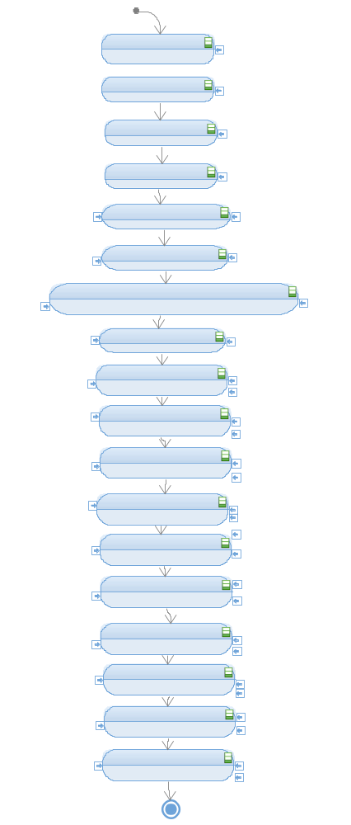

Function void segment_SetLevelBar (T_UBYTE lub_level, T_UBYTE lub_UpFlagInd,T_UBYTE lub_DownFlagInd) [DSD-17]

Description | Turns on or off the segments of the segment bar depending on the level. It represents the window, it enables and disables each segment.
Parameter 1 | T_UBYTE lub_level, indicates the level of the windows that must be reached.
Parameter 2 | T_UBYTE lub_UpFlagInd, this flag indicates if the window is moving upwards.
Parameter 3 | T_UBYTE lub_DownFlagInd, this flag indicates if the window is moving downwards.
Return Value | void
Precondition | The segment bar should have been initialized.
Post condition | The new level of the window is indicates through the segment bar.
Error Conditions | None

Dynamic Behavior
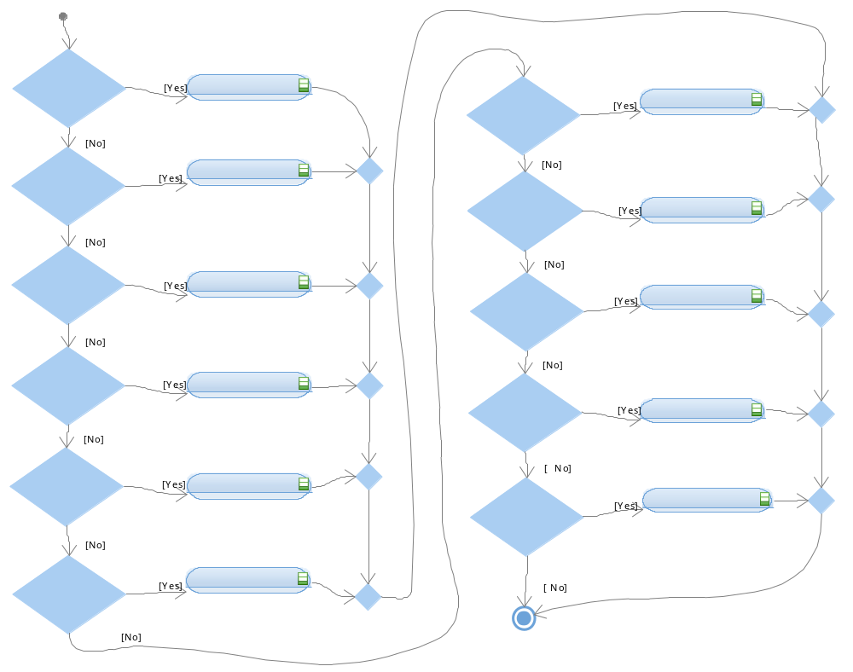

Function segmentbar_SetLevel10(T_UBYTE lub_UpFlagInd) [DSD-18]

Description | Turns on the 10th segment of the segment bar if the windows moves upwards.
Parameter 1 | T_UBYTE lub_UpFlagInd, indicates if the window is moving upwards.
Return Value | void.
Precondition | segment_SetLevelBar() should have been called.
Post condition | The 10th window´s level is shown through the segment bar.
Error Conditions | None.

Dynamic Behavior
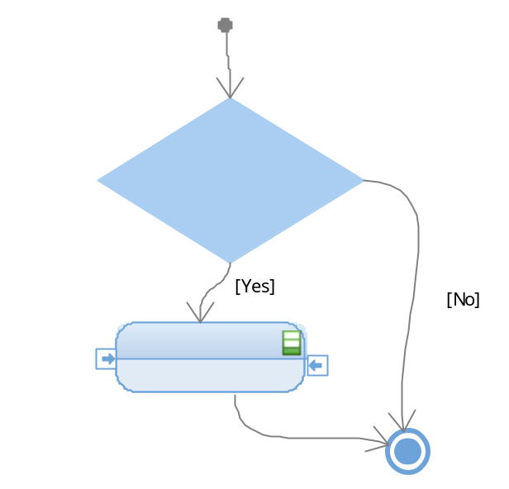

Function void segmentbar_SetLevel9(T_UBYTE lub_UpFlagInd, T_UBYTE lub_DownFlagInd) [DSD-19]

Description | Turns on the 9th segment of the segment bar if the windows moves upwards or turns off the 10th segment if it is moving downwards.
Parameter 1 | T_UBYTE lub_UpFlagInd, indicates if the window is moving upwards.
Parameter 2 | T_UBYTE lub_DownFlagInd, indicates if the window is moving downwards.
Return Value | void.
Precondition | segment_SetLevelBar() should have been called.
Post condition | The 9th window´s level is shown through the segment bar.
Error Conditions | None.

Dynamic Behavior
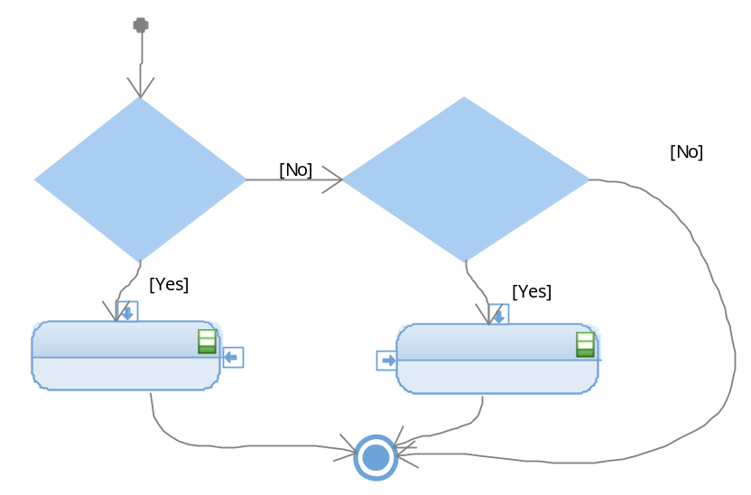

Function void segmentbar_SetLevel8(T_UBYTE lub_UpFlagInd, T_UBYTE lub_DownFlagInd) [DSD-20]

Description | Turns on the 8th segment of the segment bar if the windows moves upwards or turns off the 9th segment if it is moving downwards.
Parameter 1 | T_UBYTE lub_UpFlagInd, indicates if the window is moving upwards.
Parameter 2 | T_UBYTE lub_DownFlagInd, indicates if the window is moving downwards.
Return Value | void.
Precondition | segment_SetLevelBar() should have been called.
Post condition | The 8th window´s level is shown through the segment bar.
Error Conditions | None.

Dynamic Behavior
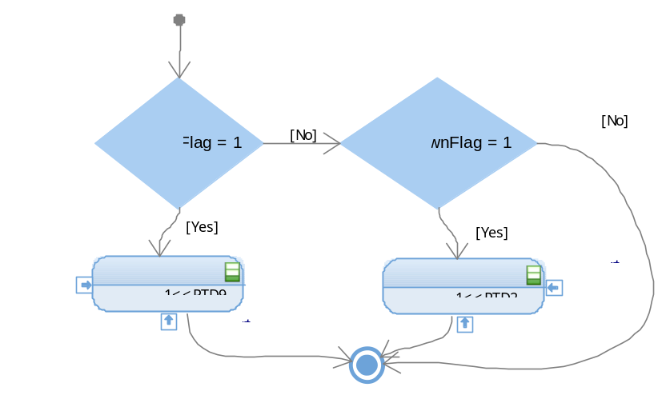

Function void segmentbar_SetLevel7(T_UBYTE lub_UpFlagInd, T_UBYTE lub_DownFlagInd) [DSD-21]

Description | Turns on the 7th segment of the segment bar if the windows moves upwards or turns off the 8th segment if it is moving downwards.
Parameter 1 | T_UBYTE lub_UpFlagInd, indicates if the window is moving upwards.
Parameter 2 | T_UBYTE lub_DownFlagInd, indicates if the window is moving downwards.
Return Value | void.
Precondition | segment_SetLevelBar() should have been called.
Post condition | The 7th window´s level is shown through the segment bar.
Error Conditions | None.

Dynamic Behavior
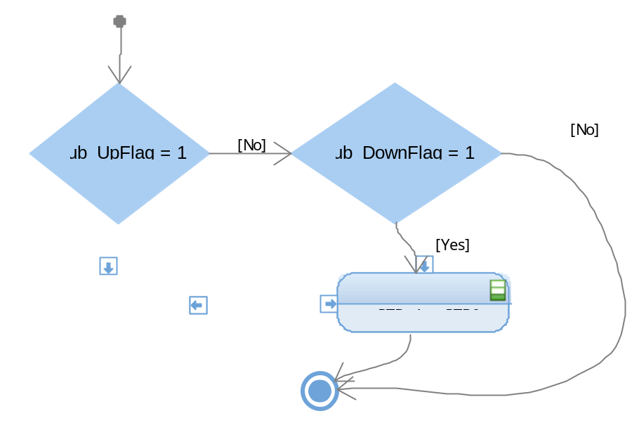

Function void segmentbar_SetLevel6(T_UBYTE lub_UpFlagInd, T_UBYTE lub_DownFlagInd) [DSD-22]

Description | Turns on the 6th segment of the segment bar if the windows moves upwards or turns off the 7th segment if it is moving downwards.
Parameter 1 | T_UBYTE lub_UpFlagInd, indicates if the window is moving upwards.
Parameter 2 | T_UBYTE lub_DownFlagInd, indicates if the window is moving downwards.
Return Value | void.
Precondition | segment_SetLevelBar() should have been called.
Post condition | The 6th window´s level is shown through the segment bar.
Error Conditions | None.

Dynamic Behavior

Function void segmentbar_SetLevel5(T_UBYTE lub_UpFlagInd, T_UBYTE lub_DownFlagInd) [DSD-23]

Description | Turns on the 5th segment of the segment bar if the windows moves upwards or turns off the 6th segment if it is moving downwards.
Parameter 1 | T_UBYTE lub_UpFlagInd, indicates if the window is moving upwards.
Parameter 2 | T_UBYTE lub_DownFlagInd, indicates if the window is moving downwards.
Return Value | void.
Precondition | segment_SetLevelBar() should have been called.
Post condition | The 5th window´s level is shown through the segment bar.
Error Conditions | None.

Dynamic Behavior
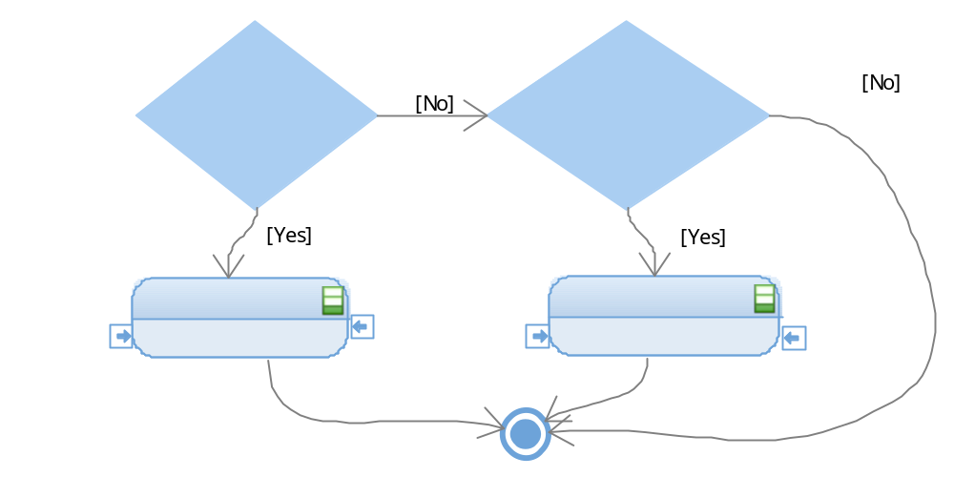

Function void segmentbar_SetLevel4(T_UBYTE lub_UpFlagInd, T_UBYTE lub_DownFlagInd) [DSD-24]

Description | Turns on the 4th segment of the segment bar if the windows moves upwards or turns off the 5th segment if it is moving downwards.
Parameter 1 | T_UBYTE lub_UpFlagInd, indicates if the window is moving upwards.
Parameter 2 | T_UBYTE lub_DownFlagInd, indicates if the window is moving downwards.
Return Value | void.
Precondition | segment_SetLevelBar() should have been called.
Post condition | The 4th window´s level is shown through the segment bar.
Error Conditions | None.

Dynamic Behavior
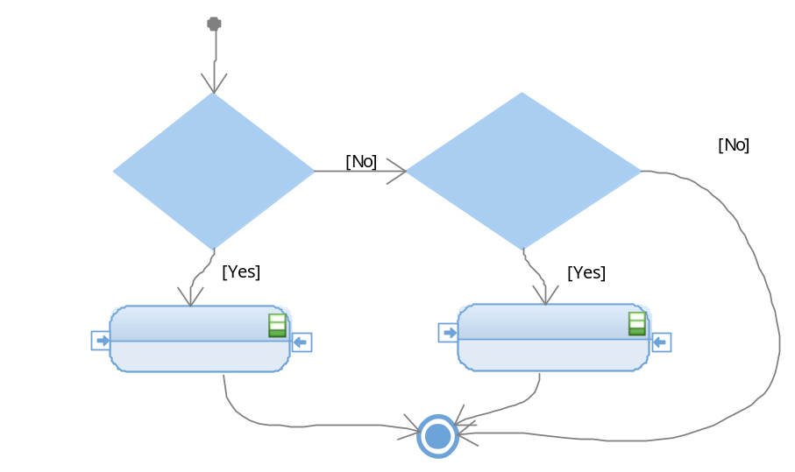

Function void segmentbar_SetLevel3(T_UBYTE lub_UpFlagInd, T_UBYTE lub_DownFlagInd) [DSD-25]

Description | Turns on the 3th segment of the segment bar if the windows moves upwards or turns off the 4th segment if it is moving downwards.
Parameter 1 | T_UBYTE lub_UpFlagInd, indicates if the window is moving upwards.
Parameter 2 | T_UBYTE lub_DownFlagInd, indicates if the window is moving downwards.
Return Value | void.
Precondition | segment_SetLevelBar() should have been called.
Post condition | The 3th window´s level is shown through the segment bar.
Error Conditions | None.

Dynamic Behavior
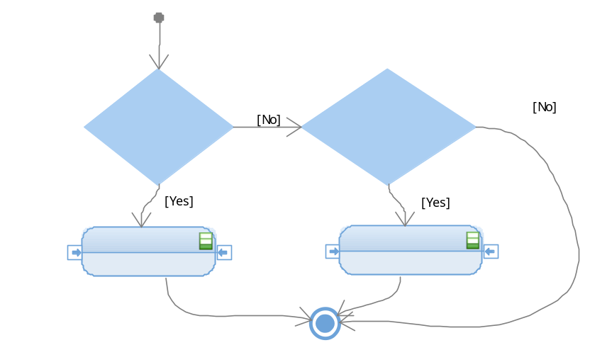

Function void segmentbar_SetLevel2(T_UBYTE lub_UpFlagInd, T_UBYTE lub_DownFlagInd) [DSD-26]

Description | Turns on the 2th segment of the segment bar if the windows moves upwards or turns off the 3th segment if it is moving downwards.
Parameter 1 | T_UBYTE lub_UpFlagInd, indicates if the window is moving upwards.
Parameter 2 | T_UBYTE lub_DownFlagInd, indicates if the window is moving downwards.
Return Value | void.
Precondition | segment_SetLevelBar() should have been called.
Post condition | The 2th window´s level is shown through the segment bar.
Error Conditions | None.

Dynamic Behavior
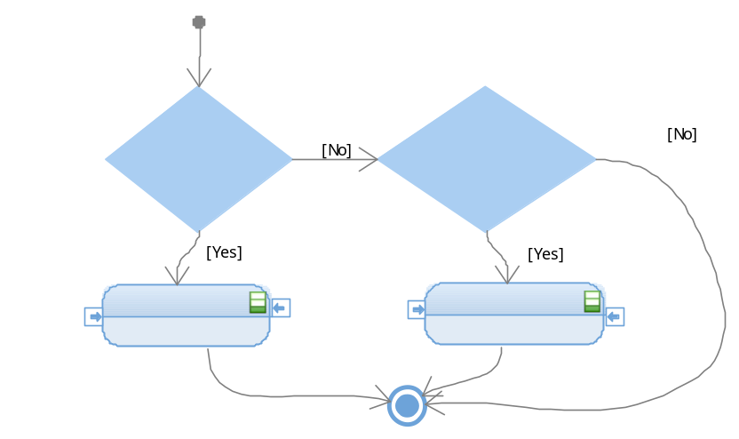

Function void segmentbar_SetLevel1(T_UBYTE lub_UpFlagInd, T_UBYTE lub_DownFlagInd) [DSD-27]

Description | Turns on the 1th segment of the segment bar if the windows moves upwards or turns off the 2th segment if it is moving downwards.
Parameter 1 | T_UBYTE lub_UpFlagInd, indicates if the window is moving upwards.
Parameter 2 | T_UBYTE lub_DownFlagInd, indicates if the window is moving downwards.
Return Value | void.
Precondition | segment_SetLevelBar() should have been called.
Post condition | The 1th window´s level is shown through the segment bar.
Error Conditions | None.

Dynamic Behavior
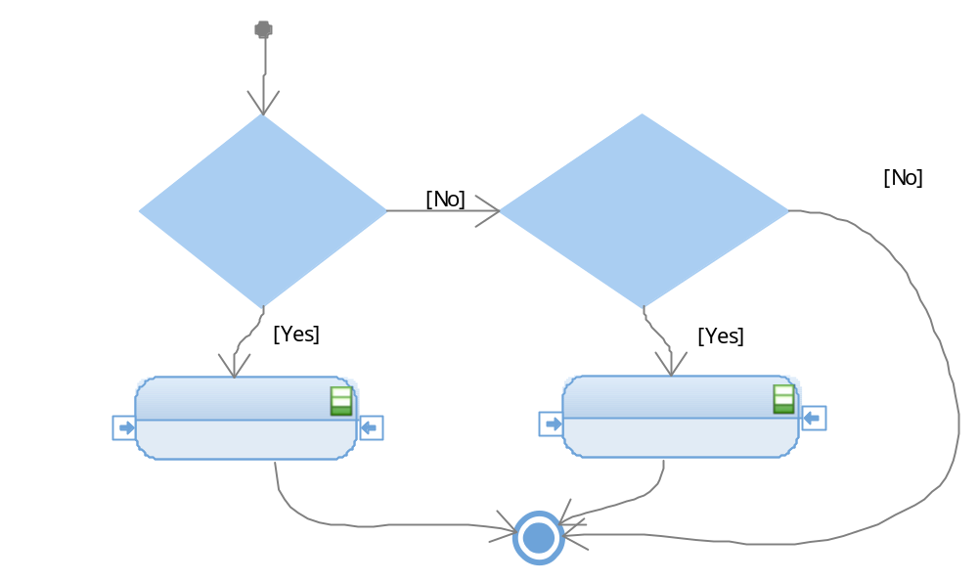

Function void segmentbar_SetLevel0(lub_DownFlagInd) [DSD-28]

Description | Turns off the 1th segment of the segment bar if the windows moves downwards.
Parameter 1 | T_UBYTE lub_DownFlagInd, indicates if the window is moving downwards.
Return Value | void.
Precondition | segment_SetLevelBar() should have been called.
Post condition | The window´s level is totally opened.
Error Conditions | None.

Dynamic Behavior
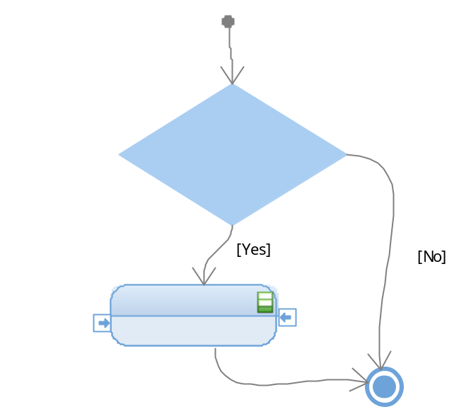

Timer

Function void timer_InitTimer (void) [DSD-29]

Description | Enables the Low Power Interrupt Timer
Parameter 1 | None
Return Value | void
Precondition | MCAL functions active
Post condition | The pins now have the new register so then they can act with some conditions.
Error Conditions | None

Dynamic Behavior
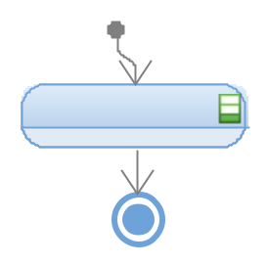

Function void timer_Wait50ms (void) [DSD-30]

Description | This function delays the time to approximately 50 milliseconds. Uses the channel 0 of the LPIT to implement the delay. Charges the delay value, enables the timer and wait until it completes the count, then clean the interrupt flag and disable the timer.
Parameter 1 | None
Return Value | void
Precondition | MCAL all function active.
Post condition | None
Error Conditions | None

Dynamic Behavior
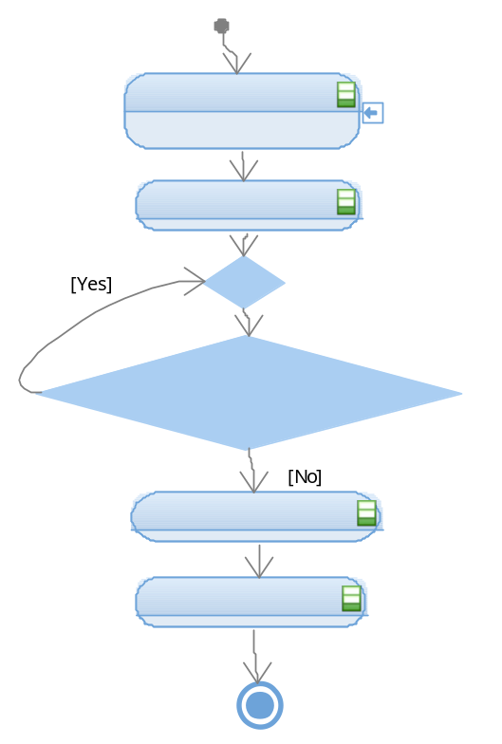

Function void timer_Wait400ms (void) [DSD-31]
Description | This function delays the time to approximately 400 milliseconds. Uses the channel 0 of the LPIT to implement the delay. Charges the delay value, enables the timer and wait until it completes the count, then clean the interrupt flag and disable the timer.
Parameter 1 | None
Return Value | void
Precondition | MCAL all function active.
Post condition | None
Error Conditions | None

Dynamic Behavior
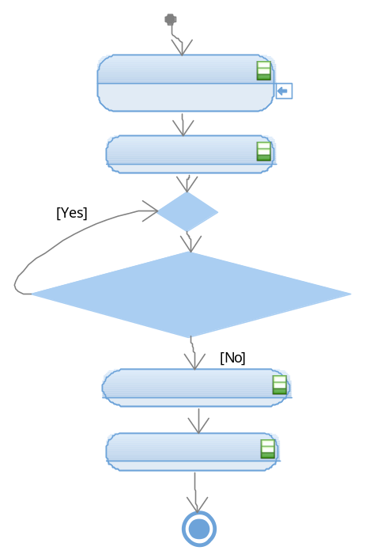

Function void timer_Wait450ms(void) [DSD-32]

Description | This function delays the time to approximately 450 milliseconds. Uses the channel 0 of the LPIT to implement the delay. Charges the delay value, enables the timer and wait until it completes the count, then clean the interrupt flag and disable the timer.
Parameter 1 | None
Return Value | void
Precondition | MCAL functions active.
Post condition | None
Error Conditions | None

Dynamic Behavior
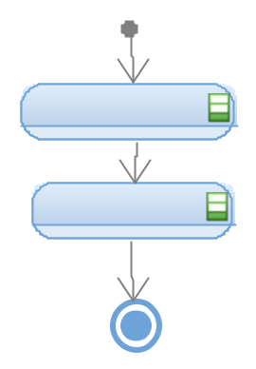

Function void timer_Wait5s (void) [DSD-33]

Description | This function delays the time to approximately 5 seconds. Uses the channel 0 of the LPIT to implement the delay. Charges the delay value, enables the timer and wait until it completes the count, then clean the interrupt flag and disable the timer.
Parameter 1 | None
Return Value | void
Precondition | MCAL all function active.
Post condition | None
Error Conditions | None

Dynamic Behavior

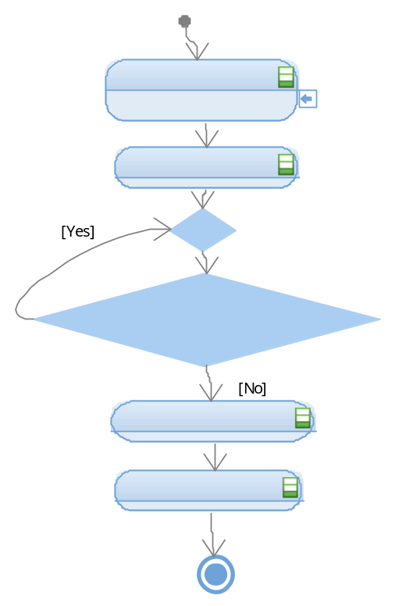

APP
APP contains five functions that allow the window’s movements and the main(). The following figure shows APP’s structure.

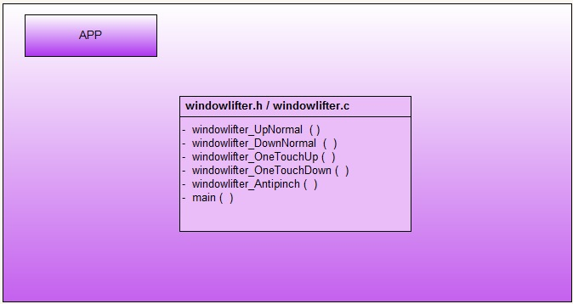

Windowlifter

Function void windowlifter_Antipinch(void) [DSD-34]

Description | Executes the Antipinch functionality
Parameter 1 | None
Return Value | Void
Precondition | The window must be moving upwards because it is designed to release the obstacle by moving the window downwards.
Post condition | None
Error Conditions | None

Dynamic Behavior
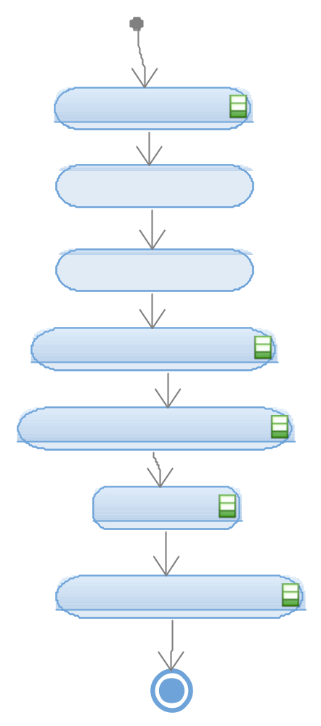

Function void windowlifter_UpNormal (void) [DSD-35]

Description | Moves the window upwards but just one stage, in other words, it implements a single transition.
Parameter 1 | None
Return Value | Void
Precondition | None
Post condition | None
Error Conditions | None

Dynamic Behavior
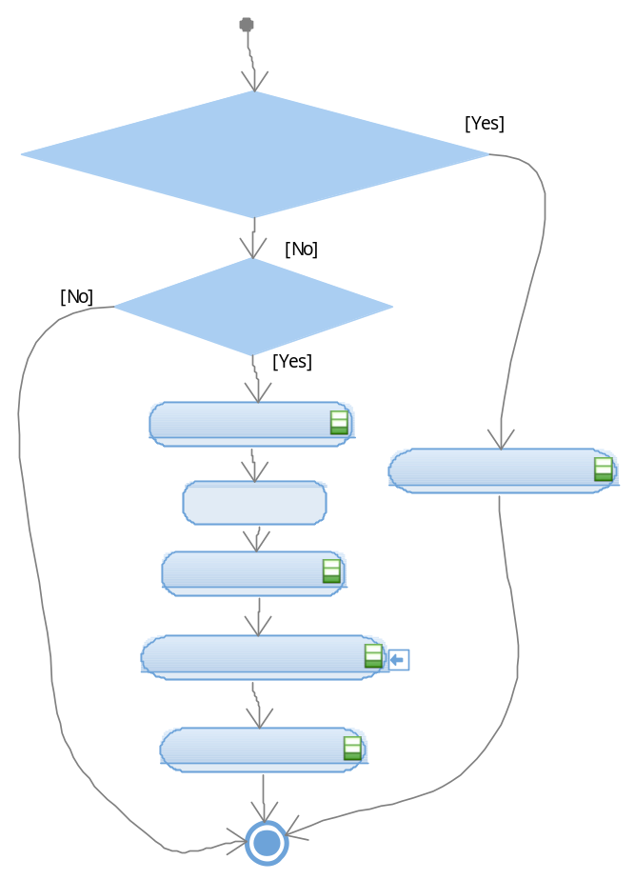

Function void windowlifter_DownNormal (void) [DSD-36]
Description | Moves the window downwards but just one stage, in other words, it shall implement a single transition.
Parameter 1 | None
Return Value | Void
Precondition | None
Post condition | None
Error Conditions | None

Dynamic Behavior

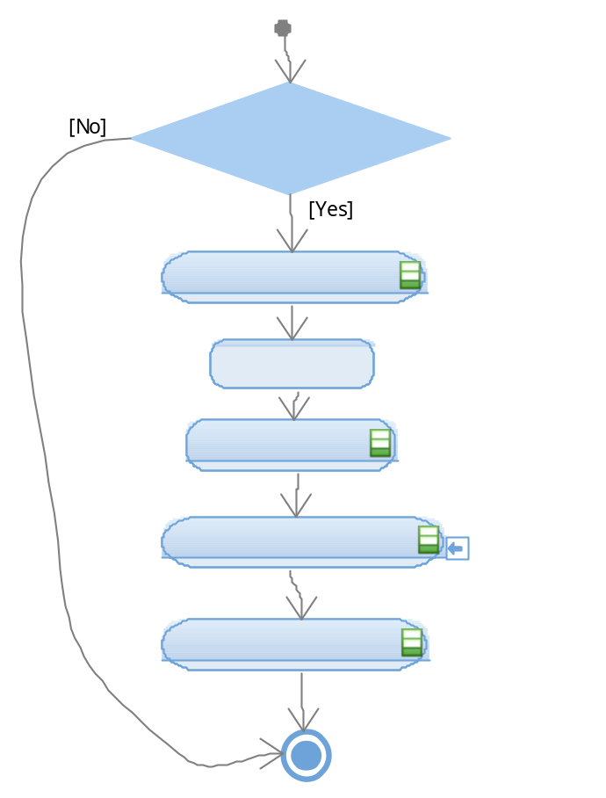

Funtion void windowlifter_OneTouchUp (void) [DSD-37]
Description | Moves the window upwards until it reaches the CLOSED stage, it can call multiple time to windorlifter_NormalUp().
Parameter 1 | None
Return Value | void
Precondition | None
Post condition | None
Error Conditions | None

Dynamic Behavior

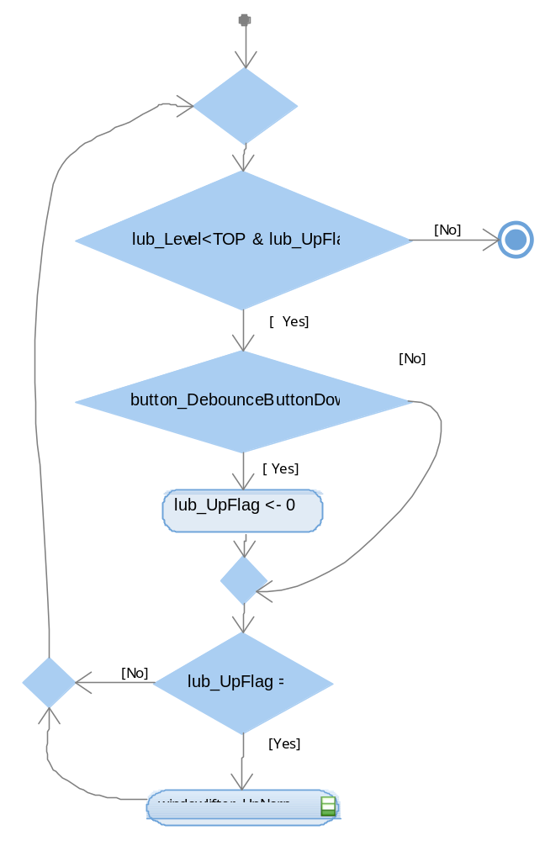

Function void windowlifter_OneTouchDown(void) [DSD-38]
Description | Moves the window downwards until it reaches the CLOSED stage, it can call multiple time to windorlifter_DownUp().
Parameter 1 | None
Return Value | void
Precondition | None
Post condition | None
Error Conditions | None

Dynamic Behavior
